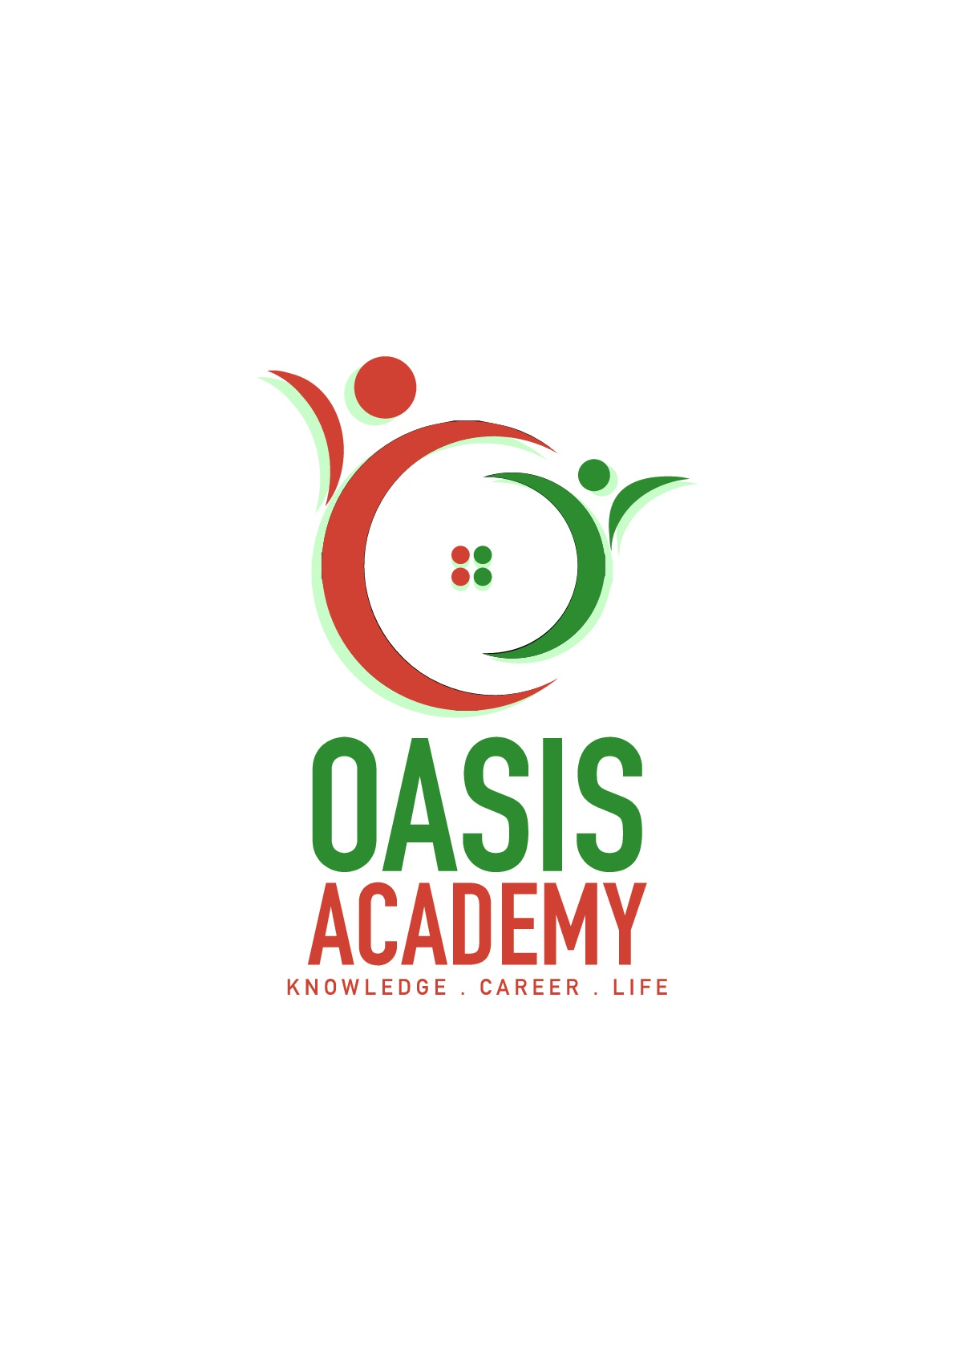

Name: Wong Ben Kim

Login ID: wongbenkim@oasis.portal.my

Course title: The Tourism and Hospitality

Subject Code: BHM04

Submitted date: 7 August 2017

**Table of Contents**

|  |  |  |
| --- | --- | --- |
| **No** | **Details** | **Page** |
| 1 | Executive Summary | 2 |
| 2 | Introduction | 3 |
| 3 | Assignment Question |  |
|  | Question 1 | 4-8 |
|  | Question 2 | 9-14 |
|  | Question 3 | 15-16 |
|  | Question 4 | 17-20 |
| 4 | Conclusion | 21 |
| 5 | References | 22-23 |
|  | Appendix | - |

**Executive Summary**

The tourism and hospitality is a part of hospitality management and I will explain about it in this assignment. In this era globalization, tourism was play a vital role in the hospitality management. This is due to the reason that the tourism is a process to help customer find a good place and let them relax and happy on their holidays. Tourism is a part of service to let customer relax and improve the knowledge of culture. Firstly I had to know how to define the Tourism, Hospitality and Hospitality Industry. Besides I have covered brief on different type of Tourism categories. Moreover I also understand about the lodging accommodation and types of Hotel accommodation. Lastly I had to know how to explain the Significant of Entertainment in this industry.

**Introduction**

In this assignment, I will explain about what I understood in the topic of Tourism and Hospitality. The tourism is a part of service to let customer enjoy on their holidays. The customer will pay the money to tourism and the tourism will find a good place and hotel to let them enjoy in the place. The customer can oversea at every country they want. Besides, tourism is a part of customer service because they need to bring the customer to the place and help them to introduce the local characteristics. They are also responsible for taking them to eat local food, shopping, accommodation and transportation problems. Tourism is a dynamic and competitive industry that requires the ability to adapt constantly to customers changing needs and desires, as the customer’s satisfaction, safety and enjoyment are particularly the focus of tourism business. Tourism constitutes a wide variety of sectors that provide diverse products and services to customers. However, these businesses also provide products and services to local residents. The hospitality is a broad category of fields with service industry that includes lodging, event planning, theme parks, transportation and additional fields with tourism industry. A hospitality unit such as hotel, restaurant, or an amusement park. Hospitality industry also use the human resources to earn the money. For example, the position of hospitality such as servers, housekeepers, porters, kitchen workers, bartenders and the management.

**Assignment Questions**

**Question 1**

Define the tourism and hospitality.

The business of giving client administration to explorers or outsiders. Cordiality experts for the most part work in managerial or administration positions in an administration based condition, and they are in charge of administering the operations and accomplishment of a foundation, for example, an inn or eatery. The accommodation and tourism industry is different, and incorporates numerous areas including RV parks, sustenance foundations, recreational offices, campgrounds, lodgings and youth inns. While the general objective of an accommodation proficient is to guarantee that visitors and clients have pleasurable encounters, they can likewise be in charge of operations, for example, employing and preparing new staff; directing office and money related organization; housekeeping, upkeep, and security staff; and promoting.

Cordiality experts additionally circulate stores, set room rates, and guarantee that the administration models of the business are met. General obligations for cordiality experts change contingent upon the span of the business and the measure of staff accessible. In bigger operations, there is normally an order of general administrators, collaborator chiefs, and bosses who work to perform operational assignments identifying with their specialized topics. In a littler business, the neighborliness proficient plays out these assignments specifically.

Some of the time accommodation proficient positions are specific. For instance, some attention on dealing with the front office, while others can be in charge of tradition administrations or money related organization. On the off chance that an accommodation proficient is utilized in a specific position, he or she should have great relational abilities and the capacity to function admirably close by collaborators in different zones of the business.

Bosses incline toward candidates with a four year college education in business or inn or cordiality administration, yet a human sciences degree alongside accommodation experience may likewise be worthy. Littler foundations may acknowledge candidates with a declaration or partner's degree in lodging, friendliness or eatery administration.

The hospitality industry is considerably more extensive than most different ventures. The larger part of business specialties are made of only a modest bunch out of various organizations, however this industry applies to almost any organization that is centered around consumer loyalty and addressing lackadaisical needs instead of fundamental ones. While this industry is extremely wide, there are some characterizing viewpoints that are vital to get it

Understanding Friendliness is partitioned into a couple of rundown, for example, characterizing angles, level of administrations, and furthermore topics.

Characterizing Perspectives. A standout amongst the most characterizing parts of this industry is that it concentrates on consumer loyalty. While this is valid for almost every business, this industry depends completely on clients' being glad. This is on the grounds that these organizations depend on giving extravagance administrations. Not very many friendliness organizations give a fundamental administration that individuals require, similar to nourishment or dress. Another characterizing aspect of this industry is its dependence on discretionary cashflow and relaxation time. For this reason, the greater part of these organizations are for travelers or rich supporters. On the off chance that discretionary cashflow diminishes because of a droop or retreat, at that point these are frequently the primary organizations to endure on the grounds that clients won't have the additional cash to make the most of their administrations.

Diverse Organizations. The vast majority imagine that inns alone belong to the friendliness business, yet lodgings are only one part of this industry. Many types of transportation that oblige travelers are likewise part of this business world. For instance, this specialty incorporates aircrafts, journey dispatches and considerably fancier trains. Eateries, general tourism and occasion arranging additionally have a place with this specialty. Some of these organizations halfway have a place with the cordiality business. For instance, a fast food eatery would be viewed as advantageous. An eatery that furnishes favor sustenance with stunning administration would be giving a cordiality benefit.

Level of Administration. Despite the business, this industry depends intensely on giving a brilliant level of administration. Clients are going by the business to make tracks in an opposite direction from their inconveniences. A terrible affair may shield them from returning until the end of time. Brand faithfulness is imperative to these clients, so the related organizations do their best to give the best administration. Organizations procure employees based on aptitude and conduct. The majority of these representatives are extraordinary with clients, and they can perfectly give the client what he or she needs.

Subjects. Another characterizing part of the friendliness business is its topic. This doesn't have any significant bearing to each business in this industry, however a considerable lot of them utilize a specific subject to pull in clients. For instance, a favor eatery may have a Mediterranean subject to pull in clients who like that kind of nourishment and climate.

Not exclusively does this separate the business from contenders, however it also allows clients to judge the business on another level. Cordiality organizations that give a bona fide topic are regularly refreshing more than general accommodation organizations. On the off chance that the above eatery cooks credible Mediterranean food and utilizations the correct improving components, at that point this will make clients glad and additionally eager to visit the business. A neighborliness business needn't bother with a topic, yet most by far of them utilize one since clients adore themed organizations.

**Question 2**

Brief on different type of tourism categories.

Any utilization of tourism and guest related terms needs to perceive that tourism is, generally, a specialized idea measured by the accessible insights of guest developments and consumption and assessments of the quantity of an extensive variety of guest offices. As an idea, tourism is unavoidably open to various translations however it is presently broadly concurred that there is a dire need to fix or accomplish more prominent exactness in the way that key tourism terms are utilized broadly, territorially and locally. Arranging and overseeing tourism when the different partners included have diverse originations of what tourism means can just ever be incompletely fruitful.

Tourism is the non specific term to cover both request and supply that has been received in different structures and utilized all through the World. Tourism is characterized as the exercises of people distinguished as visitors. A guest is somebody who is making a visit to a fundamental goal outside his/her standard condition for not as much as a year for any primary reason [including] occasions, relaxation and entertainment, business, wellbeing, training or different purposes… .This extension is considerably more extensive than the customary view of sightseers, which included just those going for recreation

Guest is the shared factor that covers every one of the types of tourism characterized above for a similar scope of purposes. The term grasps three separate classifications. Vacationers who are guests avoiding home for at least one evenings for any of the reasons noted above (household, or from abroad). Same Day guests, otherwise called traveler day guests spending no less than 3 hours from home outside their typical condition for general relaxation, recreational and social purposes. Many are neighborhood occupants of a region. Relaxation day guests spending under 3 hours from home however outside their typical condition, for general recreation, recreational or social purposes. Not incorporated these short stay relaxation day guests contribute straightforwardly to the neighborhood guest economy and ought to likewise be formally perceived in goal administration choices. The vast majority of this third gathering of guests are additionally inhabitants of goals and their neighborhood catchment zones.

The term 'tourism enterprises' is the universally acknowledged UNWTO/OECD meaning of twelve standard mechanical arrangements of the parts of the economy that give administrations devoured by guests. The turnover because of tourism in each of these segments is measured by overviews of guest consumption, is from the request side, generally in the private part however including some open area administrations. Albeit helpful and in like manner utilization by experts, the media and government officials, there is no acknowledged global or national meaning of the term 'tourism industry.'

A term now generally utilized all through the UK, despite the fact that not yet formally characterized, guest economy alludes to general request and supply in every one of the segments inside which guest movement and its immediate and roundabout outcomes upon the economy happen. The term guest economy is more extensive than the meaning of tourism enterprises, which it incorporates, and it includes all staying and non-staying guests. The term grasps the exercises and consumption engaged with providing items and administrations for guests by both the private and open segments. It likewise incorporates the principally open part exercises and generous consumption on the creation, support and advancement of people in general domain and the framework inside which, and through which, guest exercises occur. Guest economy can be utilized as a part of connection to global, national and sub-national geological goals or zones and need not really be restricted by existing chronicled limits. 'Tourism enterprises' are, accordingly, a sub-set of the guest economy.

Guest goals are places that are perceived as guest goals and for which it is conceivable to gauge parts of the interest for and supply of tourism benefits inside characterized limits. Guest goal is liked to 'tourism goal' on the grounds that by definition it incorporates all classifications of guest. Normally such goals have some type of open/private segment association set up; they are elevated as spots to visit and have some type of administration process set up for guest related purposes. At nearby level, goal limits in the UK are generally yet not generally coterminous with at least one neighborhood experts or assigned parts of such authoritative territories, for instance, National Parks. At territorial level goal limits will dependably be a blend of nearby expert organization areas. At national level the limits are those of the nation. These levels consider EU assentions zone organization. The UNWTO basically characterizes the primary goal of a tourism visit as "the place went by that is vital to the choice to take the outing."

Albeit broadly utilized all through the UK, Goal Administration is a moderately later and inexactly utilized idea still during the time spent setting up a formal definition. It is a concurred hierarchical process for driving, affecting and organizing administration of the key parts of a goal that add to a guest's experience having respect likewise for the necessities of nearby inhabitants, organizations and the earth. Successful administration requires estimation and arranging and advancement forms for the guest economy of a goal as a major aspect of general nearby specialist designs. Albeit private area inclusion is fundamental, powerful goal administration additionally requires the dynamic investment of neighborhood specialists and important open division bodies. Guest economy related associations are normally alluded to as Goal Administration Associations or DMOs. While the administration perspectives are basic to improve the potential advantages in the guest economy, most DMOs have generally been framed as advertising associations and some may not yearn for, or pick not to, incorporate the administration components noted previously. All things considered these bodies are progressively alluded to as Goal Associations.

Open domain is an acknowledged and generally utilized term in the UK for spaces for the most part uninhibitedly accessible for use by the general population. Related with normally utilized terms, for example, put molding, put making or extraordinariness of place, open domain incorporates the expenses and administration of administrations that identify with the advancement and use of spaces such as town and downtown areas, stops and plants and picturesque rustic ranges and most famous structures. Such spaces are basically the immediate duty of nearby experts subsidized by Government, neighborhood business rates, committee imposes alone income procuring exercises. A few parts of open space arrangement are frequently likewise mostly vested in other open area organizations working with neighborhood specialists. In conjunction with the general population domain and nearby expert arranging, the private segment likewise possesses and keeps up a large portion of the structures and land encompassing open spaces and now and again the home through which free is given. In the more extensive setting, open domain is dependably part of the neighborhood personal satisfaction for inhabitants it characterizes the extraordinariness and appeal of spots, and impacts internal venture by and large.

**Question 3**

Describe the lodging accommodation and types of Hotels accommodation.

The lodging offers an imperative part in exchanging organizations, meetings and recreational offices in many nations. In numerous regions, the lodging is a critical fascination for visitors to draw in customers, and they are more ready to burn through cash than at home. The lodging business is portrayed by lavish inns from extravagance resorts and campgrounds. Convenience is a totally broad branch of the inn business, including bed to breakfast business and inn to other settlement offices. Client benefit is basic for settlement administrations. This is not all, effectiveness, solace, and flawless offices are additionally the premise. An extravagance resort ought to give clients security and restrictive administrations to cut it in the specialty. They are the three primary sorts of lodgings and facilities, which is Settlement, Suite, and Resort. Settlement is when individuals head out starting with one place then onto the next, they require a place to rest, an asylum that shields them from the monstrosities of nature. This prompted a booking cabin and convenience. Suite is notwithstanding the general stay, the inn likewise offers special suites. As a rule, suites are appropriate for formal registration, which is costly contrasted with general room benefit. Resort is the third class of settlement that is prevalent among voyagers is a resort. These influence you to near nature and give you an essential rest from your formal schedules. The accompanying are a portion of the grouping of settlement; the lodging gives voyagers paid convenience and different administrations for the visitors. Contingent upon the size, area and offices, the inn is for the most part from one star to five stars yet in addition reviewed and other rating designs are likewise used to characterize lodgings around the globe. Boutique inn normally finished in a topic autonomous style, the extent of the boutique inn private, concentrated on giving visitors amazing customized involvement. Timeshare is a get-away property with shared possession and utilize rights. What's more, the decision of time-sharing rental can be a perfect decision for remaining in lodging rooms, giving quality offices and better esteem. Hikers Inn is a lodging for spending voyagers, for the most part drawing in youthful clients. The room is residence framework the restroom is shared, in spite of the fact that there might be a private room. Notwithstanding house costs, you can likewise give light dinners. A self-providing food foundation might be basically one of the other convenience sorts, yet in addition offers an exceptional smorgasbord office. The unit ought to be furnished with a completely prepared kitchen to meet the greatest number such as counting coolers, stoves, cutlery, earthenware, cookware, cleaning hardware. The kitchen ought to be elite to the visitors, not the offer.

**Question 4**

Explain the Significant of Entertainment in this industry.

Travel and diversion, regardless of whether for business or delight, are a necessary piece of our way of life. Facilities, stimulation, nourishment and drink and travel and tourism are imperative segments of the assorted neighborliness industry. For all intents and purposes each segment of this market section depends upon built foundation, quite a bit of which may have necessities that are one of a kind to the accommodation business. Banter has worked effectively over the range of the friendliness and diversion markets to address difficulties in siting, outline and development. A key part of the tourism business is attractions which offers guests an opportunity to investigate the sights, offices and marvels of their goals. Attractions by and large incorporate notable sits, legacy homes, exhibition halls, lobbies of notoriety, craftsmanship displays, professional flowerbeds, ski slopes, aquariums, zoos, water parks, diversion park,casinos and social attractions. There diversion and media outlet incorporates bunch exercises that range from fowl viewing and salmon angling to horseback riding, whitewater boating, hitting the fairway, wild trekking and instructive visits to engaging shots. Despite measure, these scenes require individuals to work in blessing shops and eateries, and in addition help keep up the offices, deal with the operations and advance the attractions.

Craftsmanship exhibition halls gather authentic and current masterpieces for instructive purposes and to save them for who and what is to come. Open exhibitions, then again, don't for the most part gather or monitor masterpieces. Or maybe, they concentrate on presentations of contemporary acts and on projects of addresses, distributions, and different occasions. The term historical center covers an extensive variety of foundations from wax galleries to sports corridors of fame. No matter what kind of exhibition hall it is, many are presently inquiring as to whether museums are still pertinent in the present cutting edge world. Accordingly, exhibition halls are utilizing new innovation to grow the guest encounter. One illustration is the Regal BC Historical center, which has an internet Learning Entrance, records late related tweets on its landing page, and is home to an IMAX theater playing IMAX motion pictures that identify with the gallery shows.

A botanical plant is a garden that showcases local and non-local plants and trees. It conducts instructive, research, and open data programs that improve open comprehension and valuation for plants, trees, and gardening.Canadian professional flowerbeds have an expected 4.5 million guests for each year and are imperative science and instructive offices, giving authority in plant preservation and state funded training .

While social and legacy attractions endeavor to display data in view of notable and developing societies and actualities, event congregations are attractions that frequently work to make substitute, whimsical substances. Amusement parks have a long history going back to the 1500s in Europe, and have developed from that point forward. Today, it is hard not to attempt to contrast any event congregation goal with Disneyland and Disney World. Opened in 1955 in radiant California, Disneyland set the standard for theme parks. The Pacific National Presentation (PNE) in Vancouver is viewed as one of BC's most conspicuous entertainment meccas and as of late commended its 100-year commemoration (PNE, 2015).

The Universal Word reference of Occasion Administration characterizes a celebration as an open festival that passes on, through a kaleidoscope of exercises, certain implications to members and spectators. Other definitions, including those utilized by the Ontario Trillium Establishment and the European Union, feature openness to the overall population and brief span as key components that characterize a festival.The wide nature of celebrations has prompt the advancement of characterization types. For occurrence, financing for the federal government's Building People group through Expressions and Legacy Program is accessible under three classes, contingent upon the kind of celebrations. Neighborhood celebrations subsidizing is provided to nearby gatherings for repeating celebrations that present crafted by neighborhood specialists, craftsmans, or recorded entertainers. Group commemorations financing is provided to nearby gatherings for non-repeating neighborhood occasions and capital ventures that remember a commemoration of 100 years. Heritage subsidizing is provided to group capital tasks that celebrate a 100th commemoration of a critical neighborhood recorded occasion or nearby verifiable identity.

**Conclusion**

In the nutshell, the tourism and hospitality is a part of customer server to make the customer happy at their holiday. For example, the customer will pay the tourism and hospitality to plan a trip for them. Thus, they need to make sure the customer can enjoy their trip by them plan. Example, Any utilization of tourism and guest related terms needs to perceive that tourism is, generally, a specialized idea measured by the accessible insights of guest developments and consumption and assessments of the quantity of an extensive variety of guest offices. As an idea, tourism is unavoidably open to various translations however it is presently broadly concurred that there is a dire need to fix or accomplish more prominent exactness in the way that key tourism terms are utilized broadly, territorially and locally. Arranging and overseeing tourism when the different partners included have diverse originations of what tourism means can just ever be incompletely fruitful.

**Reference**

http://www.besthospitalitydegrees.com/faq/what-exactly-is-the-hospitality-industry/

https://www.visitbritain.org/introduction-tourism

http://www.tourismsociety.org/page/88/tourism-definitions.htm

http://yourbusiness.azcentral.com/three-categories-hospitality-industry-24003.html

https://www.wisdomjobs.com/e-university/hotel-front-office-management-tutorial-369/types-of-lodging-facilities-12982.htmt

https://www.hotwire.com/helpcenter/hotels/searching-and-booking/locations-properties-reservatio

ns/what-different-lodging-types.jsp

http://www.luxuryaccommodationsblog.com/post/114961446726/different-types-accommodation-tourism

http://www.tc.gov.yk.ca/tourism.html

https://opentextbc.ca/introtourism/chapter/chapter-1-history-and-overview/

https://www.beyond.com/tourism/defined

https://www.merriam-webster.com/dictionary/tourism

http://www.besthospitalitydegrees.com/faq/what-exactly-is-the-hospitality-industry/

THE END